**PE VIVA MONDAY BATCH**

**BHAI ANS BHI LIKH DO PLZ**

* **How to decide Step Size?**

*(The question was ambiguous as it is not clear whether factors deciding step size were asked or method of setting step size was asked.)*

The primary factor deciding step size is the maximum frequency of a signal in the circuit.

And the method of setting step size is in powergui block and in model settings

* **How to find Harmonic Spectrum?**

By FFT Analysis.

* **What is the Distortion factor?**
* **0**

Ratio of Fundamental RMS to True RMS.

* **When does the mode of operation change from CCM to DCM in the Buck-Boost converter?**

Decrease Duty ratio or increase Rload or decrease L or decrease switching frequency.

At k<kcrt, kcrt=(1-d)^2 -->DCM ELSE CCM

* **CD(circuit diagram) of buck converter**

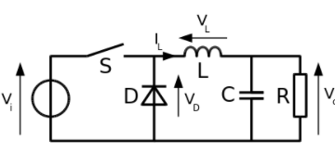

* **What happens if the inductor is shorted in the buck converter? What changes are observed in voltage across the mosfet switch?**

2 VOLTAGE SOURCE IN PARALLEl i.e capacitor and DC source

If the inductor saturates or overloaded extremely, it will behave as a short, the current will increase very rapidly and will break your MOSFET and possible other components

* W**hy is the driver circuit used?**
* **Cosine Triggering vs Linear triggering. Why do we need cosine triggering if it is easier to generate sawtooth waves/Linear triggering.**

Cosine triggering me hum cosine wave aur reference voltage use krke switching Instant generate krte hai..

Linear triggering me we use sawtooth wave and reference voltage.

Cosine triggering is difficult to develop lekin agar cosine triggering use kre toh control parameters jo milega using feedback from output uska transfer function simple hoga.. Toh controller design easy hoga.

Ye dekh lo cosine and linear triggering jisko bhi dekhna hai

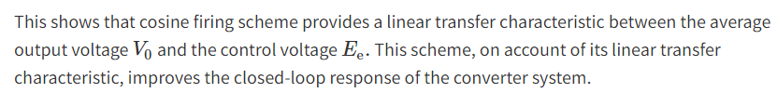

* **What is a freewheel diode? Uses. Change in PF due to freewheeling diode.**

Freewheeling diodes are used to protect the circuit from unusual damage caused due to abrupt reduction in the current flowing through the circuit. It is also known as **Flyback diode** and forms a connection across the inductor to remove Flyback voltage generated across it.

The presence of Flyback diode gives an alternate path to the current, produced due to Flyback voltage at the inductor.

majorly finds applications in full-wave rectifiers, relay drivers and H-bridge motor drivers etc.

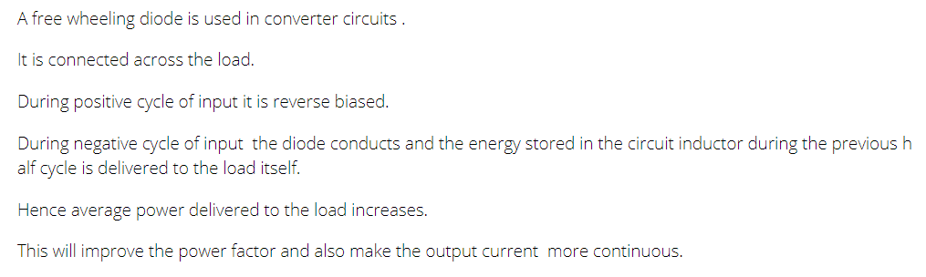

* **Why do we need commutation? How does it happen? What happens in commutation failure actually.**

Commutation is nothing but the turn OFF method of an SCR. It is one method used to bring an SCR or thyristor from ON state to OFF state when required for power controlling otherwise power conditioning.

### **Natural Commutation**

Generally, if we consider AC supply, the current will flow through the zero crossing line while going from positive peak to negative peak. Thus, a reverse voltage will appear across the device simultaneously, which will turn off the thyristor immediately.

### **Forced Commutation**

The thyristor can be turned off by reverse biasing the SCR or by using active or passive components.

**Decrease of voltage and voltage distortion** is the main reason causing commutation failure.

system **is greatly disturbed resulting in loss of power transmission**. Moreover, the rapid in- crease in the direct current during unsuccessful commutation results in additional stresses on the thyristor valves.

* **For the same Vin and Vout, which one is better? Buck or buck-boost? Why?**

Buck as voltage ripple across switch is less.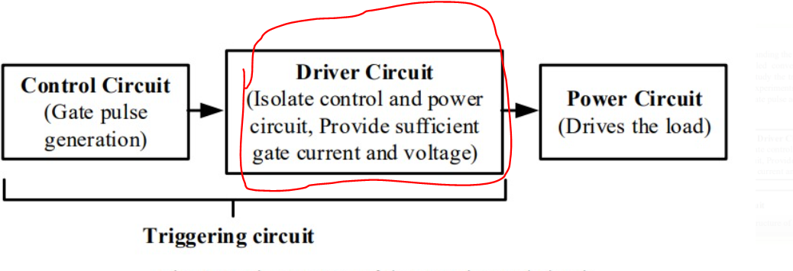

* Which DC DC converter is used in the lab?
* Current ripple dependence on frequency

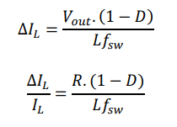

* Commutation circuit diagram

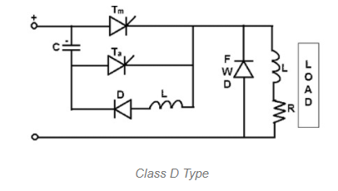

* Semi-controlled, fully-controlled rectifier output voltage expression and diagram
* How to turn on thyristor?

Vanode>Vcathode

* How thyristor turns off in rectifier?

During the negative half-cycle as the load current becomes zero, then the thyristor will turn off. If voltage exists for a period of the rated turn off time of the device, then the negative polarity of the voltage across the outgoing thyristor will turn it off.

**Question arrange karo yaar**

**Q. Why train of pulses are used to turn on the thyristor instead of a single pulse?**

I. Holding the gate at trigger voltage for longer duration will cause huge power dissipation within the thyristor and draw excess power from the trigger circuit.

II. At the start of a conduction interval, thyristor may not latch on with the first firing pulse because the current may not reach the minimum holding current. So we need to keep on triggering until it latches on. Hence we use a train of pulses to turn on the thyristor.

**Q. Why is flyback converter used even when we have buck?**

* Flyback mei transformer bhi hota..toh turns ratio se apne hisaab ka output laana aasan ho jaata hai… kyuki buck wagera mei bas duty ratio output decide karta hai.
* Flyback mei multiple outputs saath mei handle kar sakte hain.
* Keeps circuit elements safe through isolation.

**Q. Flyback mai clamp ckt kyu add kiya:**

* Leakage current ke liye
* becuase there might be a leakage inductance and so in off condition we have to provide a path for ti

**Q. Ac-Dc rectifier me source inductance ka effect on output voltage**

* Source induction ke liye commutation interval badhega.. Toh kuch duration ke liye 2 thyristor on same line on ho jayega... Toh isiliye output voltage km hoga